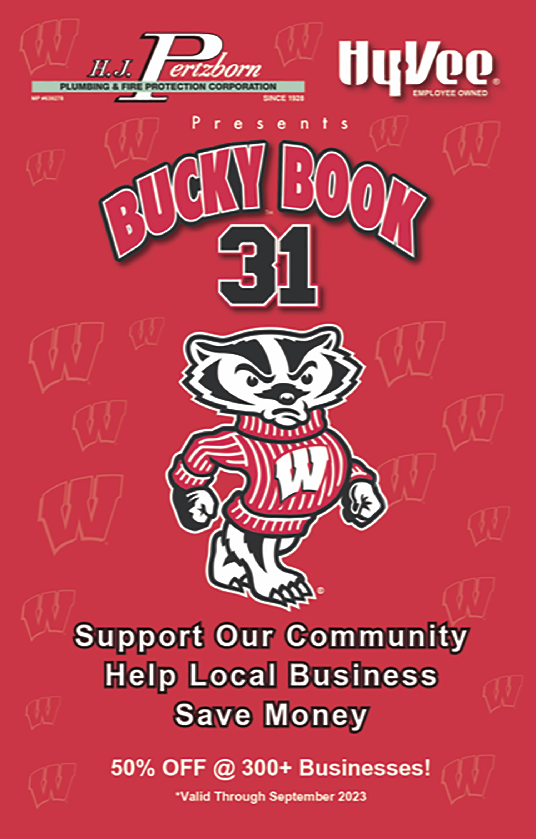  each Book comes with…  A KWIK TRIP FLYER with 50% car washes & beverages! | SELF-SELLING FLYER  This flyer is good for students, kids & members who you set goals for.  It contains training on how to sell Bucky Books and forms to track their sales. We suggest you ask each participant to sell 3 books but mention our “Sell 5 books get 1 FREE” bonus (mentioned on flyer) for those “go-getters.”  This does not mention the Kwik Trip premiums which are included with each Bucky Book so everyone selling will need to know that info to help their sales.

Approach your family, friends, neighbors, co-workers, Dentist, Doctor, mechanic, postal worker, set up a booth in front of the grocery store, go door to door (if allowed), etc.

You won’t convince everyone but don’t give up! People will say
“I don’t use coupons” or “I forgot to use it last time,” etc. but use this magical phrase and you’ll do fine.

#1 SELLING TIP!

“If you use just a few coupons you’ll repay yourself
for the book and it WON’T COST YOU A DIME
to help our group…can you help please?”

Then you can continue with…
“They’re valid until next September so in the next year
I’m sure you can find just one or two coupons to repay yourself then it will cost you nothing to support our
group and our community. Who knows, you might
actually save $100s more like many people do!”

If they don’t buy right away use these examples:

“There’s over 30 golf courses offering 2 for 1 (valid thru next year) so
if you golf, or know a golfer, just one coupon pays for your book!”

Plus, 50% OFF car washes & food at Kwik Trip
which pays for your book alone!

“There’s over $200 in half off groceries at Hy-Vee and Woodman’s which more than pays for your book!”

“If you have kids, you’ll save a ton on half off birthday parties, bouncy houses, bowling, ice cream, UW Games, Dane Co. Fair, swimming, amusement parks PLUS there’s a WI Dells section too!”
TIPS & TRACKING TO SELL BUCKY BOOKS!
Copy and pass this out to your volunteers.
YOUR NAME & #: _______________________________________

Complete a block for each customer you sell. Cash or check is preferred credit card is accepted. A receipt will be emailed to the customer by the Bucky Book for any credit card (CC) payments.

BONUS! Sell 5 books and get 1 FREE!

Customer ___________________________________________________________
Billing Address________________________________________________________
City______________________________________ State_________ Zip__________
Phone___________________ Email______________________________________
CC #________________________________________ Exp _________ CVV ______
# Books_______ Total Payment $____________ Check_____ Cash_____ CC_____

Customer ___________________________________________________________
Billing Address________________________________________________________
City______________________________________ State_________ Zip__________
Phone___________________ Email______________________________________
CC #________________________________________ Exp _________ CVV ______
# Books_______ Total Payment $____________ Check_____ Cash_____ CC_____

Customer ___________________________________________________________
Billing Address________________________________________________________
City______________________________________ State_________ Zip__________
Phone___________________ Email______________________________________
CC #________________________________________ Exp _________ CVV ______
# Books_______ Total Payment $____________ Check_____ Cash_____ CC_____

Customer ___________________________________________________________
Billing Address________________________________________________________
City______________________________________ State_________ Zip__________
Phone___________________ Email______________________________________
CC #________________________________________ Exp _________ CVV ______
# Books_______ Total Payment $____________ Check_____ Cash_____ CC_____

