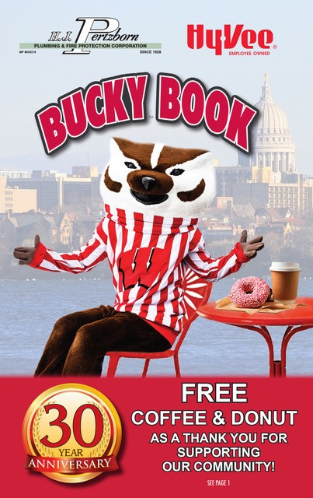  To celebrate BUCKY BOOK’S 30 YEAR ANNIVERSARY each Book comes with an ABSOLUTELY FREE Coffee & Donut from Dunkin Donuts AND A KWIK TRIP FLYER with 50% car washes and beverages! | WELCOME!  Below is a flyer for your group to get people involved with your Bucky Book fundraiser.  Once you know your process of collecting funds, whether its direct and/or order taking orders via email/phone, etc., type it in where you see the red in the flyer.  NOTE: We are now accepting credit cards as that convenience may help sales. Not all groups are doing that but if you’d like, in addition to having the credit card info on the form, you could enter a contact person and number and/or email in the red area to provide that alternative; otherwise, you can just type “Sorry, no credit cards accepted.”  Good luck!

Dear Group Members, Families and Supporters,

Thank you for being a valued supporter of our organization. With your help we can support our group while saving you money! The BUCKY BOOK is celebrating their 30th ANNIVERSARY and can help us too!

1) Our group will receive $15 FROM EACH $35 BUCKY BOOK SOLD!
2) Your participation will help raise much needed funds for our cause.

3) Redeem just a few coupons (sometimes just one!) to repay yourself then it will COST YOU NOTHING TO HELP OUR GROUP!

We are asking you to participate by either:
1) Purchasing one Bucky Book for you or your family to save!
It can COST YOU NOTHING…and you could save $100s more!

2) AND/OR take one or two Bucky Book(s) to sell!

BONUS! Receive 1 FREE Book if you purchase 5! Help by selling to family, friends, neighbors, co-workers OR keep some for holiday gifts.

Please return this form to your contact OR email (contact person or people) at (email) OR call (contact person) at (phone #) to place your order.

I would like to purchase _____ Bucky Book(s) at $35 each by cash or check (preferred) or credit card. Please complete appropriate info below:

Name____________________________________________________
Billing Address_____________________________________________
City__________________________ State_______ Zip_____________
Cell________________________ Home________________________
Email____________________________________________________
CC #_____________________________Expire__________ CVV_____
# Books_________ x $35 ea. = Total Payment $_________________

If paying by credit card please be patient for your processing as our group gathers other orders. You will receive a receipt via email once the payment has been processed. Thank you for your support!

The Bucky Book contains hundreds of
50% OFF and 2 FOR 1 coupons at 300+ businesses!
- KWIK TRIP! $35+ in Kwik Trip savings! (all WI locations)
- GROCERIES! $200+ at Hy-Vee, Woodman’s & others
- GOLF! $3,000+ in 2 FOR 1 golf valid through next year
- DINING, FAST FOOD & PIZZA! $3,000+ in savings at 100+ local restaurants
- ENTERTAINMENT! $600+ in savings on family fun including the Dells!
- PLUS 50% OFF & 2 FOR 1! Shopping, Health & Beauty, UW Sports, Pet Services/Food, Carpet Cleaning, Home Care & more

If you’re not a big coupon user that’s OK…but please review the savings above and below AND visit BuckyBook.com. If you can find $35 out of $20,000+
in half off savings PLEASE CONSIDER HELPING!

To celebrate Bucky Book’s 30th Anniversary and as a “THANK YOU FOR YOUR SUPPORT” you’ll also receive…
A FREE Coffee & Donut from Dunkin Donuts!
AND
A Kwik Trip flyer with 50% OFF
car washes, beverages & food!

“There’s Kwik Trip coupons & a flyer with 50% OFF car washes, beverages & food which pays for your book alone!
“There’s over 30 golf courses with 2 for 1s (valid thru next year) so if you know a golfer just one coupon pays for the book!”

“There’s over $200 in half off groceries at Hy-Vee, Woodman’s and more which more than pays for your book!”

“For kids you have half off birthday parties, bouncy houses, bowling, ice cream, UW Games, Dane Co. Fair, roller skating, amusement parks, etc. PLUS there’s a WI Dells section too!”

